COST Action CA20139: "Holistic design of taller timber buildings"
Management Committee Meeting
Minutes
07/10/2024 at 10:00:00
Virtual, N/A, Slovenia
N/A, N/A, Slovenia
1. Welcome to participants, verification of the quorum and adoption of agenda
Chair welcomed participants to the meeting and shared the agenda. Quorum was not reached.

2. Information to the MC
a) Recap of the minutes of the last meeting, e-votes and matters arising since the last meeting
The minutes are available online.
5 e-votes were passed since the last MC Meeting.
- Vote on fund transfer (approved 15.6.2024)
- Vote on core group mandate to approval or refusal of WG applications – (approved 16.8.2024)
- Vote on core group mandate to reallocate budget up to 10.000€ (approved 18.8.2024)
- Change of country affiliation of Action Vice Chair Robert Jockwer (approved 28.9.2024)
- Special issue in Wood Material Science & Engineering (approved 30.9.2024)
b) Core Croup: report from the Core Group, including delegated decisions
4th Working Group Meeting & MC Meeting, Hasselt, Belgium
- 22.-24.5.2024
- Attendance 117 participants (expected 110)
- To be reimburse 61 (expected 90)
- 39 (33%) ITC, 46 (39%) Female, 55 (47%) ECI

Training School 2024 – Sustainability of Taller Timber Buildings, Zagreb, Croatia
- 19.-21.6.2024
- Attendance 33 participants (expected 36)
- 9 (27%) ITC, 12 (36%) Female, 26 (79%) ECI
c) Action Membership: New Specific Organisations and COST Members represented in the MC
MC participants
- 65 MC members
- 34 COST Member countries
- 18 ITC Member countries

d) Action Participation: WG membership and applications, New MC Members/Observers
and provisional substitution.
WG participants
- 398 participants
- 44 countries

Working groups
- WG 1: 174 participants
- WG 2: 159 participants
- WG 3: 143 participants
- WG 4: 209 participants

Chair asked if we should keep the Action open to everyone. Tacit agreement with members in attendance.

e) Budget status: summary from the Grant Holder.
Action Chair gave an update on the budget used. For the Skopje meeting claims are still being processed. Additional budget was approved via e-vote for STSMs and other grants.
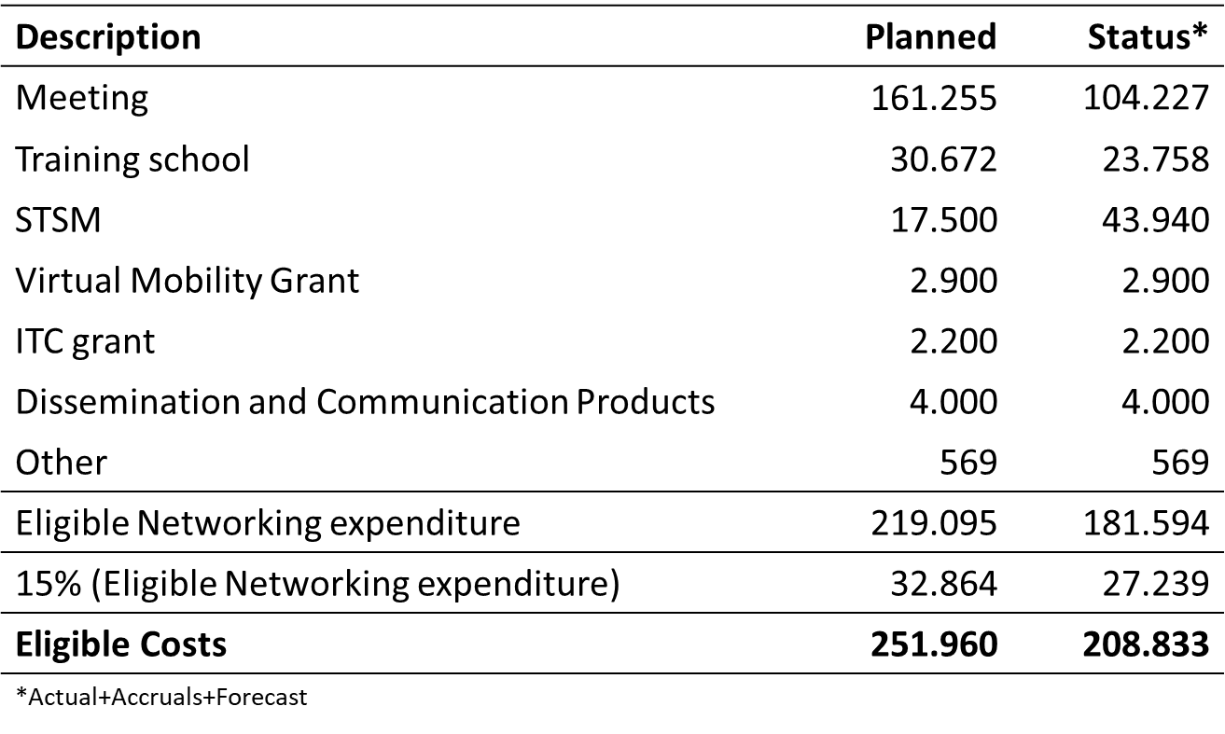
f) Update from the COST Association (if representative is present)
Representative was not present.

3. Follow up and discussion on the
a) Action management: structure, leadership positions and other supporting roles.
Mandates to the Core Group (if applicable)
There have been no changes to the management structure.
b) Implementation of the COST Excellence and Inclusiveness Policy
- 18 out of 34 COST member countries are ITC
- 143 out of 398 members are ITC (36%)
- 217 out of 398 members are ECI (55%)
- 123 out of 398 members are female (31%)
- ITC, gender and ECI criteria are taken into consideration when inviting people for in-person attendance as well as STSM granting
- 2023 New leadership position: Diversity, Equity and Inclusion Coordinator

c) Grant Awarding by the Action
Selection criteria
- Relevance to tall timber buildings – quality of proposal
- ECI
- ITC – geographical diversity
- Gender balance
- Available funds
- (Longer stays)

GP 3:
- 17 STSM (12 ongoing)
- 3 ITC grant
- 1 VM (1 ongoing)
- ECI: 88%
- ITC: 59%
- Female: 24%
Finished STSMs
- M. Salehi (NMBU, Norway) to Linnaeus University (Sweden)
- B. Kurent (Ljubljana, Slovenia) to EMPA (Switzerland)
- O. Kaplan (Eskisehir, Turkey) to Zagreb (Croatia)
- U. Kavka (Innorenew) to TU Wien (Austria)
- Čolić (Edinburgh, UK) to UBC (Canada)

Ongoing STSMs
- V. Belafonte (Minho, Portugal) to Aarhus (Denmark)
- J. Barbalić (Zagreb) to Czech Technical University (Czechia)
- Dapieve Aquino (Minho, Portugal) to Politecnico di Milano (Italy)
- Petrovski (Skopje, North Macedonia) to Ljubljana (Slovenia)
- Aloisio (L’Aquila, Italy) to Oslo (Norway)
- Y. Wang (KTH, Sweden) to NMBU (Norway)
- L. Vojnović (Bristol, UK) to Lund (Sweden)
- M. Roso (Torino, Italy) to Madrid (Spain)
- Alex S. Cao (ETH, Switzerland) to Lund (Sweden)
- T. Tatar (Sakarya, Turkey) to Innorenew (Slovenia)
- Kurent (Ljubljana, Slovenia) to L’Aquila (Italy)
- H. Sivrikaya (Bartin, Turkey) to Göttingen (Germany)

ITC & Virtual mobility grants
- Edgars Kuka (Latvia), 11th European Conference on Wood Modification
- Ahmed Can (Turkey), Wood & Fire Safety
- F. Mascarenhas (Portugal), International Scientific Conference on Hardwood Processing
- Benjamin Božić (Slovenia), Heatmap

d) Progress of each working group
WG 1: Design for Adoption, Reuse and Repair
- WG and SG meetings (online)
- Merging of SGs to consolidate topics and focus activities
- Further work on topics identified in the STAReport and in meetings with other WGs (e.g. damage/repair)
- Working on Springer book chapters
- Support of STSMs

WG 2: Deformations and Vibration
- WG and SG meetings (online)
- Working on Springer book chapters
- Support of STSMs

WG 3: Accidental Load Situations
- Establish an active subgroup for multi-hazard design for accidental load situations (e.g., seismic, fire, blast, etc.) with the goal to develop a multi-hazard design framework for TTBs
- Continue working on topics regarding fire and seismic load situations
- Start developing draft Guidelines for taller timber buildings, building on the State-of-the-Art Report (STAR)
- Lay the groundwork for Year 4 WG3 activities, which will involve the publication of white papers, guidelines, conference papers, etc.
- Support of STSMs

WG 4: Sustainability and Durability
- WG and SG meetings (online and in person)
- Training School on "Sustainability of Taller Timber Buildings"
- Working on Springer book chapters
- Support of STSMs

e) Science Communication Plan
Science Communication Plan is available on our website. It is currently updated and will be available soon.

Upcoming communication products are outlined below:
Special Issue of “Wood Material Science & Engineering”
- We aim for up to 16 scientific articles (proposal contained 21 abstracts)
- Very positive response from the editor
- Timeline (main authors have been informed last week):
- Submission of manuscripts via the Taylor & Francis system by 31 January 2025.
- Authors will receive reviewing results by March 2025.
- Final submission of revised papers for acceptance no later than May 2025.
- Open access: waiting for the response from T&F

Book with results from the Action published by Springer
- Open access (11.650€ for up to 400 pages, 14.350€ for 600 pages)
- Book production: 4 months
- Timeline (authors will be informed soon):
  - 1st draft by 31 December 2024
  - Submission (version to be reviewed) by 28 February 2025
  - Authors will receive reviewing comments by 31 March 2025.
  - Final submission by 16 May 2025.
- 55 contributions (each approx. 8 pages)
- Short summaries of the SI articles (2-4 pages)
- Approx. 500 pages
- Book structure:
  - I – Introduction
  - II - Planning of TTB - ULS & SLS design
  - III - Hazard criteria IV - Moisture and durability
  - V - TTB in the Use phase (Structural assessment)
  - VI - Circularity of TTB (Reuse, recycling, repair)
  - VII – Special aspects for the design of TTB
There was a discussion about publishing the special issue in open access. Member noted that open access is important and worth a high price.
f) Progress on MoU Objectives, WG tasks, deliverables, and Goals for the current GP.
There are no significant changes in progress on MoU Objectives. Progress has been made.
Discussion of items that are underway including planning the final conference and publishing the heatmap on our website. Chair plans to change the planned deliverables for the heatmap via an e-cost vote.

Deliverables – All are in the expected state except the heatmap, which had a few challenges due to data privacy policy. Chair recommends that we try to finalize the heatmap during this year, so the results can be published in the Springer book.

Suggestion was made to rename to final publication, currently “Taller Timber Building Design Guidelines”.

4. Planning
a) Revision of Work and Budget Plan of the current GP (if applicable)
b) Draft plans for the following GP(s).
Final conference
Location: Tallin (Estonia)
Date: Thursday 5.6.2025 (previously planned in September 2025)
1 full day with dinner in the evening
Number of reimburse participants: 80
Estimated budget: 69.520€ (excl. VAT)

MC meetings
MC meeting #7 – online January/February 2025
MC meeting #8 – online June/July/August 2025

Training school
Title: Case studies in Taller Timber Buildings
Description: invite practitioners involved in timber construction to present their experience in specific topics (e.g. seismic design, acoustics, fire safety, off and on site construction processes, architectural challenges).
Location: Zurich (CH)
Date: 19.-20.5.2024
Trainees: 40
Trainer: 6
Estimated budget: 38.965€ (excl. VAT)

Short Term Scientific Missions (STSM) grants
Expected number: 6 (might be increased)
Estimated budget: 12.000€ (excl. VAT)

ITC Conference grants
Expected number: 5
Estimated budget: 5.500€ (excl. VAT)

VM grants
Expected number: 1
Estimated budget: 1.500€ (excl. VAT)

Special Issue of “Wood Material Science & Engineering”
We aim for up to 16 scientific articles (proposal contained 21 abstracts)
Very positive response from the editor
Timeline (main authors have been informed last week):
Submission of manuscripts via the Taylor & Francis system by 31 January 2025.
Authors will receive reviewing results by March 2025.
Final submission of revised papers for acceptance no later than May 2025.
Open access: waiting for the response from T&F
Book with results from the Action published by Springer
Open access (11.650€ for up to 400 pages, 14.350€ for 600 pages)
Book production: 4 months
Approx. 500 pages

Member noted that the final conference may conflict with the Compwood conference in Vienna during 4-6. June 2025.

Member suggested to increase the number participants at the final conference and that the open access fees are an important expense.

c) Upcoming activities
Continuation of working in the WG
Interactive survey (heatmap)
Training school
Final conference
Special Issue of “Wood Material Science & Engineering”
Book with results from the Action published by Springer

5. Monitoring and Reporting to the COST Association
2nd Progress Report (PR2)
The Rapporteur summary has been presented during MC #5

Final Assessment (FA)
Status: not initialized
Support from WG members to collect:
- Co-authored Action publications
- Projects resulting from Action activities
- Other outputs / achievements

6. AOB
Chair received an email from one participant with a list of concerns and he would like to discuss two issues:
- Sharing slides and other working material
  - There is no common shared location for working documents. WGs, SGs, and ad hoc groups are using various tools for data management, namely to share documents. Given that the Action is approaching its end, it is preferred to keep the current approach.
  - Chair asks for input from MC members about sharing slides and working material. The following issues have been addressed during the discussion:
    - Privacy concerns: If we move material to another folder, all members need to approve this
    - Long-term storage: concern that the WG share folders will disappear due to affiliations and folder subscriptions like Dropbox.
  - Summary of discussion:
    - There is no need to change the current approach to the data management, i.e. WGs, SGs, continue using their approach for sharing data.
    - Long-term storage solution for documents that are not published as "official" publications should be explored.

- Distribution of individual requests (e.g. calls for open PhD positions) via email
  - To date, the Chair has rejected individual requests because he doesn’t want to spam the Action members and he also doesn’t want to decide about the relevance of each individual request.
  - Chair asks for input from MC members about the distribution of individual requests via email. The following issues have been addressed during the discussion:
    - WG1 has a share folder called a “Call for Collaboration” folder. WG members can use the folder to share requests.
    - Email list should be used to WG information and communication only. The distribution of PhD position would be a misuse of the mail list.
  - Summary of the discussion: The participants agree that we should continue with current policy of not disseminatingg individual requests.
7. Summary of MC decisions
No MC decisions because quorum was not reached.

8. Closing
Chair thanked participants for their attendance and participation.

